Chapter 7: Read the Nature
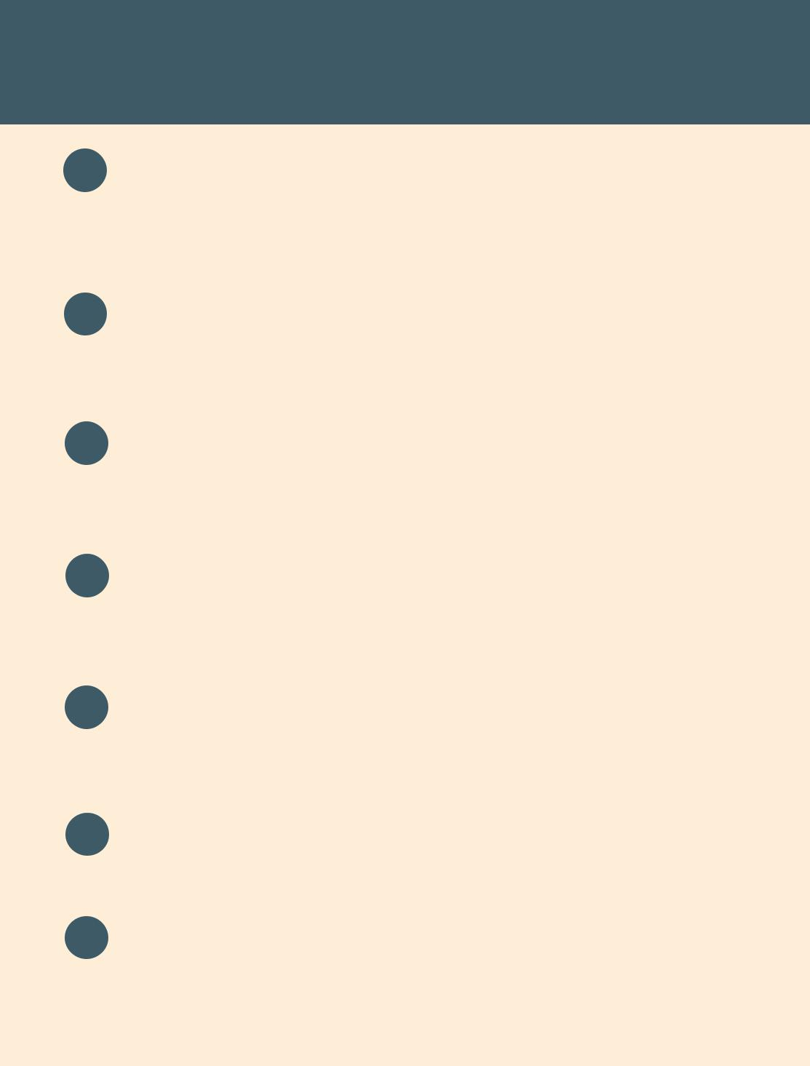

Tujuh Pembelajaran:

Setelah mempelajari Bab 7, siswa diharapkan mampu:

- Mensyukuri kesempatan dapat mempelajari bahasa Inggris sebagai bahasa pengantar komunikasi International yang diwujudkan dalam semangat belajar.

2.1 Menunjukkan perilaku santun dan peduli dalam melaksanakan komunikasi interpersonal dengan guru dan teman.

2.2 Menunjukkan perilaku jujur, disiplin, percaya diri, dan bertanggung jawab dalam melaksanakan komunikasi transaksional dengan guru dan teman.

2.3 Menunjukkan perilaku tanggung jawab, peduli, kerjasama, dan cinta damai, dalam melaksanakan komunikasi fungsional.

3.6 Menganalisis fungsi sosial, struktur teks, dan unsur kebahasaan pada teks ilmiah berbentuk factual report tentang binatang.

4.9 Menangkap makna dalam teks ilmiah faktual (factual report) lisan dan tulis tentang binatang.

4.10 Menyusun teks ilmiah faktual (factual report) lisan dan tulis tentang binatang dengan memperhatikan fungsi sosial, struktur teks, dan unsur kebahasaan yang benar sesuai konteks.


- Kelas XII SMA/MA/SMK/MAK

A. WARMER

Can you identify the humorous points of these jokes?


1. Waiter, how long will my sausages be?

Oh about three inches.

2. Why didn’t the man die when he drank the poison?

Because he was in the living room.

3. What’s the difference between a jeweler and a jailer?

A jeweler sells watches, and a jailer watches cells.

- Why is six scared of seven?

Because 7-8-9.

- How do bees travel?

They take the buzz.

B. OBSERVING AND QUESTIONING

Listening

Task 1: Comprehension Questions
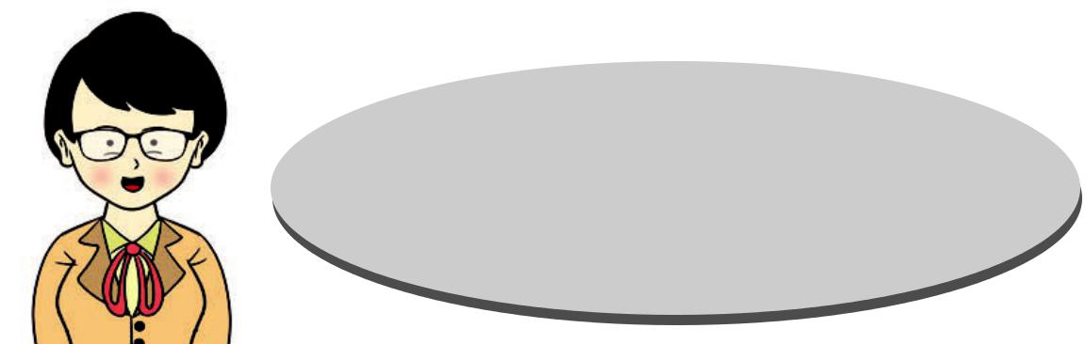

Your teacher is going to read a text about Tsunami. Listen carefully and later you will have to answer the questions.


Bahasa Inggris | 97

- What is a tsunami?

- What are tsunamis often called?

- How fast can tsunami waves travel according to National Oceanic and Atmospheric Administration (NOAA)?
- When does the speed of tsunami waves slow down?

- How long can the tsunami waves last?

Task 2: Oral Description
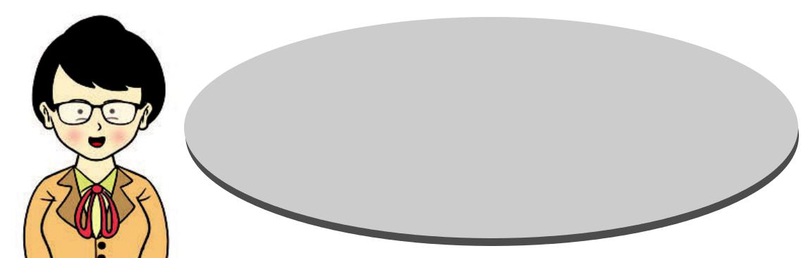

Listen to your teacher again.

You will be asked to answer some questions. After that, you will work in pairs to describe what tsunami is.

Reading

Task 1: Think about it.



Before you read the following text about tornadoes,

talk what you know about in your groups.

Use the following questions as hints.

- Do you know what a tornado is?

- What does a tornado look like?

- Where do you think a tornado is usually found?

- Where did you find information about tornado for the first time?

- Kelas XII SMA/MA/SMK/MAK

Source: picturesforcoloring.com Picture 7.1 A Tornado

Task 2: Comprehension questions

The word tornado comes from Spanish language and means to twist or turn. A tornado is a whirlwind produced by atmospheric conditions, mainly extremely low pressure, during

a severe thunderstorm. Tornadoes usually turn
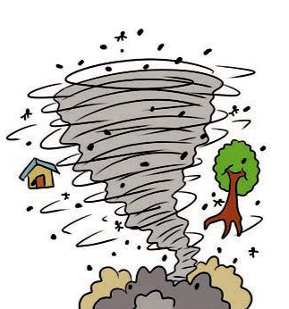
counterclockwise. They appear as funnel shaped columns of violently rotating winds that reach down from a storm and touch the ground. Although a tornado is not always visible to the eye, tornadic conditions can still be picked up on radar, or the tornado may become visible once debris and dirt are pulled into it.

A tornado may also be referred to as a funnel cloud, but this is technically not a correct term. While

the two words are sometimes used interchangeably, a funnel cloud is different, not in its make up, but in the fact that it does not touch the ground. Another name that is often used to describe a tornado is twister, due to its violent twisting motion.

The tornado is one of the most unpredictable and destructive forces of nature, often destroying everything in its path. A tornado is usually preceded by severe storms, which may include lightning, high winds, and frequent hail. It can change course without notice, and is usually accompanied by a roaring sound, or as some describe it, the sound of freight train.

(Taken from http://www.wisegeek.com/what-is-a-tornado.htm)

Bahasa Inggris | 99

Read the text above carefully, and then answer these questions briefly.

- What does the word tornado mean?

- What is a tornado?

- How do tornadoes usually turn?

- What do tornadoes look like?

- What are the other names of tornadoes?

- Why is it technically not correct to refer tornadoes as funnel clouds?

- Why is a tornado described as a twister?

- What usually precedes a tornado?

- What usually accompanies a tornado?

- What does the word some in the last line refer to?

Vocabulary Builder

Task 3: Find the meaning of words.

After reading the text about tornado, individually guess the meaning of each word below. Then, check them with your friends. When necessary, consult your dictionary. After that, practice pronouncing the words.

s e v e r e : /sɪˈ vɪr /

Source: picturesforcoloring.com Picture 7.2 A dictionary
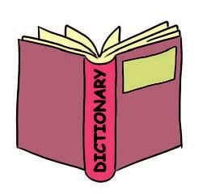

c o u n t e r c l o c k w i s e : / ˈ k a ʊ n t ə r ˈ k l ɑ ː k w a ɪ z /

v i o l e n t : /ˈ vaɪələnt /

v i s i b l e : /ˈ vɪzɪb ə l /

i n t e r c h a n g e a b l y : /ˌ ɪntəˈ tʃeɪndʒəblɪ/

d e b r i s : /dəˈ briː/

m a k e u p : /meɪk ʌp/

d e s t r u c t i v e : /dɪˈ strʌktɪv /

p r e c e d e : /prɪˈ siːd/

c o u r s e : / kɔːrs /


- Kelas XII SMA/MA/SMK/MAK

Grammar Review

Task 4: Observe the present verbs.

Look through the text again. You will find verbs like comes, means, is, turn, appear, and reach. They are called the Simple Present Tense. Observe these sentences.

The word “tornado” comes from Spanish language.

The word means to twist or turn.

A tornado is a whirlwind produced by atmospheric conditions.

Tornadoes usually turn counterclockwise.

They appear as funnel shaped columns of violently rotating winds.
They reach down from a storm and touch the ground.


Underline some other present verbs

in the text!

Do you know why some verbs end with –s (e.g., comes, means) and some other verbs do not (e.g., turn, appear)? Discuss with your friends!

Text Structure

Task 5: Observe the text structure.

The text about tornado above is called a factual report (information report). A factual report aims to provide information about natural or social phenomena. In this case, the text about tornado is an example of natural phenomena.

Bahasa Inggris | 101

How are factual reports written? The first paragraph of a factual report gives us a classification containing some general information about the phenomena, in this case, tornado (e.g., the origin of the word). All the paragraphs that follow contain some description about tornado; the description provides details. The description answers to these questions: What is it? What does it look like? What special features does it have?


Read the text again, and then

write in the table below the appropriate questions about tornados that the paragraphs will answer.


Parts of the Text | Questions to Answer
 | Paragraph 1:
Classification | Where does the word tornado come from?
 | What does it mean?
Description | Paragraph 2:
Description | What do tornadoes look like?
 | Paragraph 3:
 | What special features do tornadoes have?
 | Paragraph 4:
 | What other special feature do tornadoes have?

C. COLLECTING INFORMATION

Task 1: Read the text below carefully, and then practice reading it aloud. Mind your pronunciation and intonation.

A tsunami is a giant wave (or series of waves) created by an undersea earthquake, volcanic eruption or landslide. Tsunamis are

- Kelas XII SMA/MA/SMK/MAK

often called tidal waves, but this is not an accurate description because tides have little effect on giant tsunami waves.

Far out in the ocean, tsunami waves don’t get very high, but they move very fast. In fact, the National Oceanic and Atmospheric Administration (NOAA) reports that tsunami waves can travel as fast as a jet plane.

As a tsunami gets closer to land and the ocean depth decreases, the speed of the tsunami wave slows down and the height of the tsunami wave increases dramatically—along with its potential for destruction.

One thing is certain about tsunamis: they are unpredictable. Once a tsunami makes landfall, the waves can last from five to fifteen minutes and do not follow a set pattern. NOAA warns that the first wave may not be the largest.

Not all undersea earthquakes or other seismic events create tsunamis, which is why tsunamis are difficult to predict.

(The article is taken from: http://environment.about.com/od/environmentalevents/f/ what-is-a-tsunami.htm)

Task 2: Observe the present verbs.


Look through the text again.
Underline all the verbs in the present
forms like in the following example.

A tsunami is a giant wave (or series of waves) created by an undersea earthquake, volcanic eruption or landslide. Tsunamis are often called tidal waves, but this is not an accurate description because tides have little effect on giant tsunami waves.

Bahasa Inggris | 103

Task 3: Find a factual report text.

In groups, find a factual report text about natural phenomena. You can go to the library or search in the Internet. Use the following questions to help you select the text.

- What is the natural phenomenon?

- What does the phenomenon look like?

- What features does the phenomenon have?

- What other features does the phenomenon have?


Present your text neatly and attractively so that the other groups want to read it. Take turn sharing the information you have with the class.

Task 4: Find the present verbs.


Look through your text again.
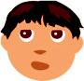

Rewrite the sentences that have present verbs. Compare what you have with other groups.

___________________________________________________

___________________________________________________

___________________________________________________

___________________________________________________

___________________________________________________

___________________________________________________

___________________________________________________

___________________________________________________

___________________________________________________

___________________________________________________

___________________________________________________

- Kelas XII SMA/MA/SMK/MAK

D. ASSOCIATING

Task 1: Vocabulary Exercise

Fill in the blanks with the appropriate words. Consider the contexts of the sentences in choosing the right words.

severe | anticlockwise | course | violent
visible | debris | interchangeably
make up | destructive | precede

- The occurence of cyclones is usually characterized by inward spiraling winds that rotate ____________ in the Northern Hemisphere and clockwise in the Southern Hemisphere of the Earth.

- This ____________ material moves according to the wind direction.

- Scientists can hypothesize that certain signs of natural phenomena ____________ certain events.

- Environmental education is useful in minimizing

____________ behaviors to the environment.

- Once the building was destroyed, the social workers had to work hard to clean up and remove all the
____________.

- Pilots depend on coordinates to ensure that they are in the right ____________.

- ____________ behaviors might be caused by severe mental illness.

Bahasa Inggris | 105

- The team had to work very hard how to find ways to

____________ their loss in the prestigious match.

- We are very sorry to hear that our friend is experiencing a ____________ brain damage after the car accident.

- The students just learned from the teacher’s explanation that the two terms are used ____________ in science.

Task 2: Grammar Exercise

Put the verbs in the brackets into the correct present form.

- Many people (use) the Internet to do electronic shopping.

- Much of the giant panda’s way of life still (remain) a mystery.

- Scientists (learn) natural phenomena from time to time.

- Catatumbo Lightning (occur) only over the mouth of the Catatumbo River where it (empty) into Lake Maracaibo.

- Like most land crabs, red crabs (use) gills to breathe and (take) great care to conserve body moisture.

- The remains of a Caribbean hurricane (threaten) to sweep away summer’s warm weather this weekend with gale-force winds and heavy rains.

- All snakes (have) teeth, but only poisonous snakes (have) fangs.

- Snow (have) an open and therefore soft, white, and fluffy structure, unless subjected to external pressure.

- Kelas XII SMA/MA/SMK/MAK

- Tropical cyclogenesis (describe) the process of development of tropical cyclones.

- Seen from Earth, Mercury (appear) to move around its orbit in about 116 days, which (be) much faster than any other planet.

Task 3: Speaking

Some natural phenomena include flood, earthquakes, landslides, or rainy season. In groups, find some information about one natural phenomenon as assigned by your teacher. You can go to the library or search in the Internet. Use the following questions to help you.

- What is the natural phenomenon?

- What does the phenomenon look like?

- What features does the phenomenon have?

- What other features does the phenomenon have?

Present what your group has found in front of the class. Use pictures or other necessary media to help clarify your presentation.

Task 4: Writing (Create your own).


Now write a factual report. Choose a natural phenomenon that is worth sharing. You can go to the library or search in the Internet to find help. Use these subheadings when writing.

Bahasa Inggris | 107

- Classification (General information about the natural phenomenon)

- Description: Details about the features of the phenomenon.


Do not forget to write and present your text neatly and attractively.

Task 5: Peer Editing
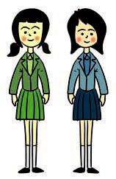

Work in pairs. Exchange your writing. Check your friend’s writing. Pay attention to these points when reading it.

1. The text structure: classification (general information) and description (details about

the features)

- Language features: the simple present tense

- Spelling

- Punctuation

- Capitalization

- Formatting

Source: picturesforcoloring.com Picture 7.3 Peer Editing

E. COMMUNICATING

Task 1: Cloze Description


Fill in the blanks with

appropriate words.

- Kelas XII SMA/MA/SMK/MAK

(Adapted from https://www.ifrc.org/en/what-we-do/

Volcanic eruptions happen when lava and gas are discharged from a volcanic vent. The most common consequences of this are population movements as large numbers of ____________

are often forced to flee the moving lava flow. Volcanic eruptions often ____________ temporary food shortages and volcanic ash landslides called Lahar.

The most dangerous ____________of volcanic eruption is referred to as a 'glowing avalanche'. This is ____________ freshly erupted magma forms hot pyroclastic flow which has temperatures of up to 1,200 degrees. The pyroclastic ____________ is formed from rock fragments following a volcanic explosion, the flow surges down the flanks of the ____________ at speeds of up to several hundred kilometers per ____________, to distances often up

to 10 kms and occasionally as far as 40 kms from the original ____________ site.

disaster-management/about-disasters/definition-of-hazard/volcanic-eruptions/)

Task 2: Writing


Rearrange the following

sentences to form

a good paragraph.

- Nest building is an instinct.

- Cardinals and thrushes make this kind of nest.

- Birds do not learn to build nests.

- Some swallows make their nests in a hole in a tree or rock.

Bahasa Inggris | 109

- They line the bottom of the hole with grass, feathers, fur, and moss.
- Many birds make a cup-shaped nest out of twigs and grass.

R E F L E C T I O N

Do you know how to create a factual report? Respond to these questions to check whether you understand how to create a factual report about natural phenomena.


- Do you use general information to introduce your topic as a classification?
- Do you give necessary description

(specific features) using subheadings?

- Do you use present verbs?

- Do you pay attention to spelling, punctuation, capitalization, and formatting?
- Do you use references?

Source: www.123trf.com


- Kelas XII SMA/MA/SMK/MAK

